Week – 02-Operator and expressions.managing input and out put operations

Week -02-01Practice Session – Coding

Reg No : 241801289

Name: Tamil selvan.K

(Q1)

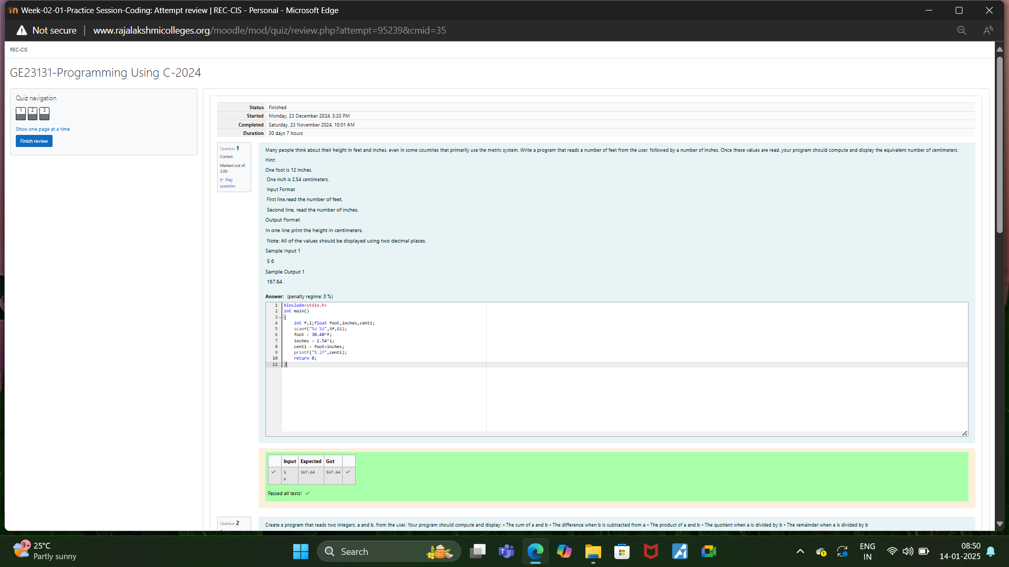

Week -02-01Practice Session – Coding

Reg No : 241801289

Name: Tamil selvan.K

(Q2)

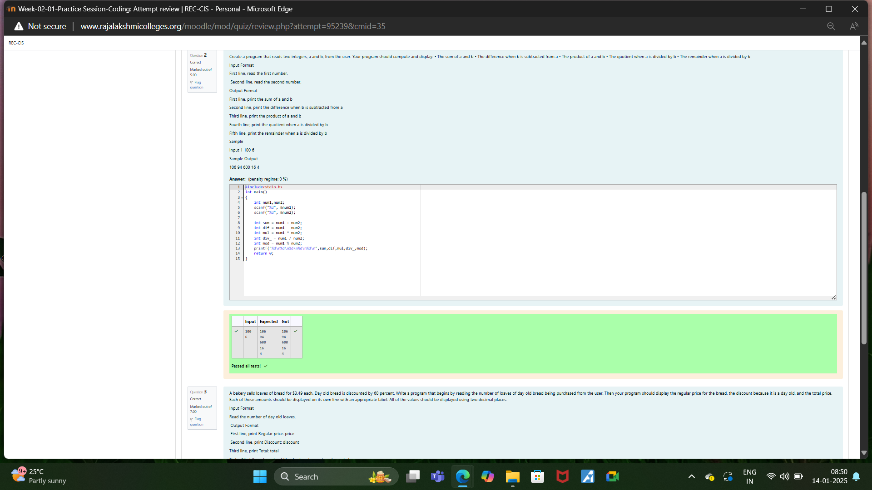

Week -02-01Practice Session – Coding

Reg No : 241801289

Name: Tamil selvan.K

Q3

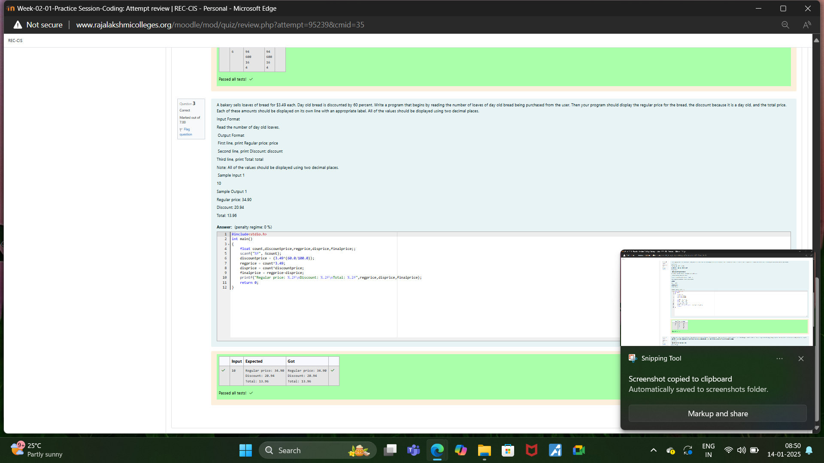

Week -02-02Practice Session – Coding

Reg No : 241801289

Name: Tamil selvan.K

Q1

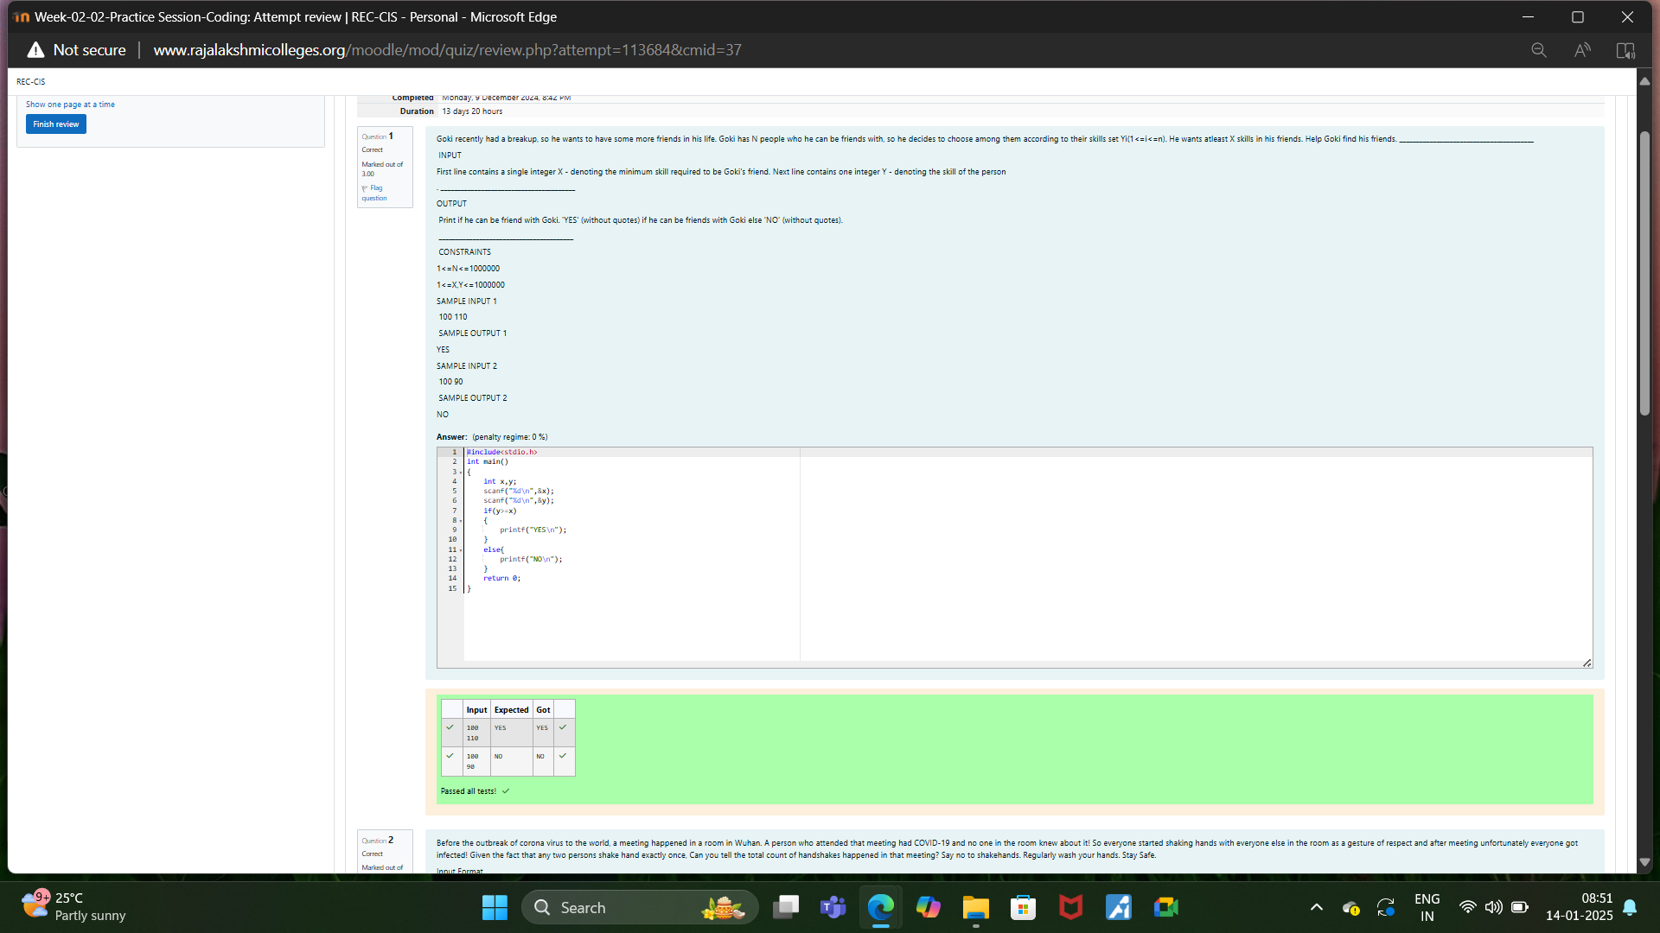

Week -02-02Practice Session – Coding

Reg No : 241801289

Name: Tamil selvan.K

Q2

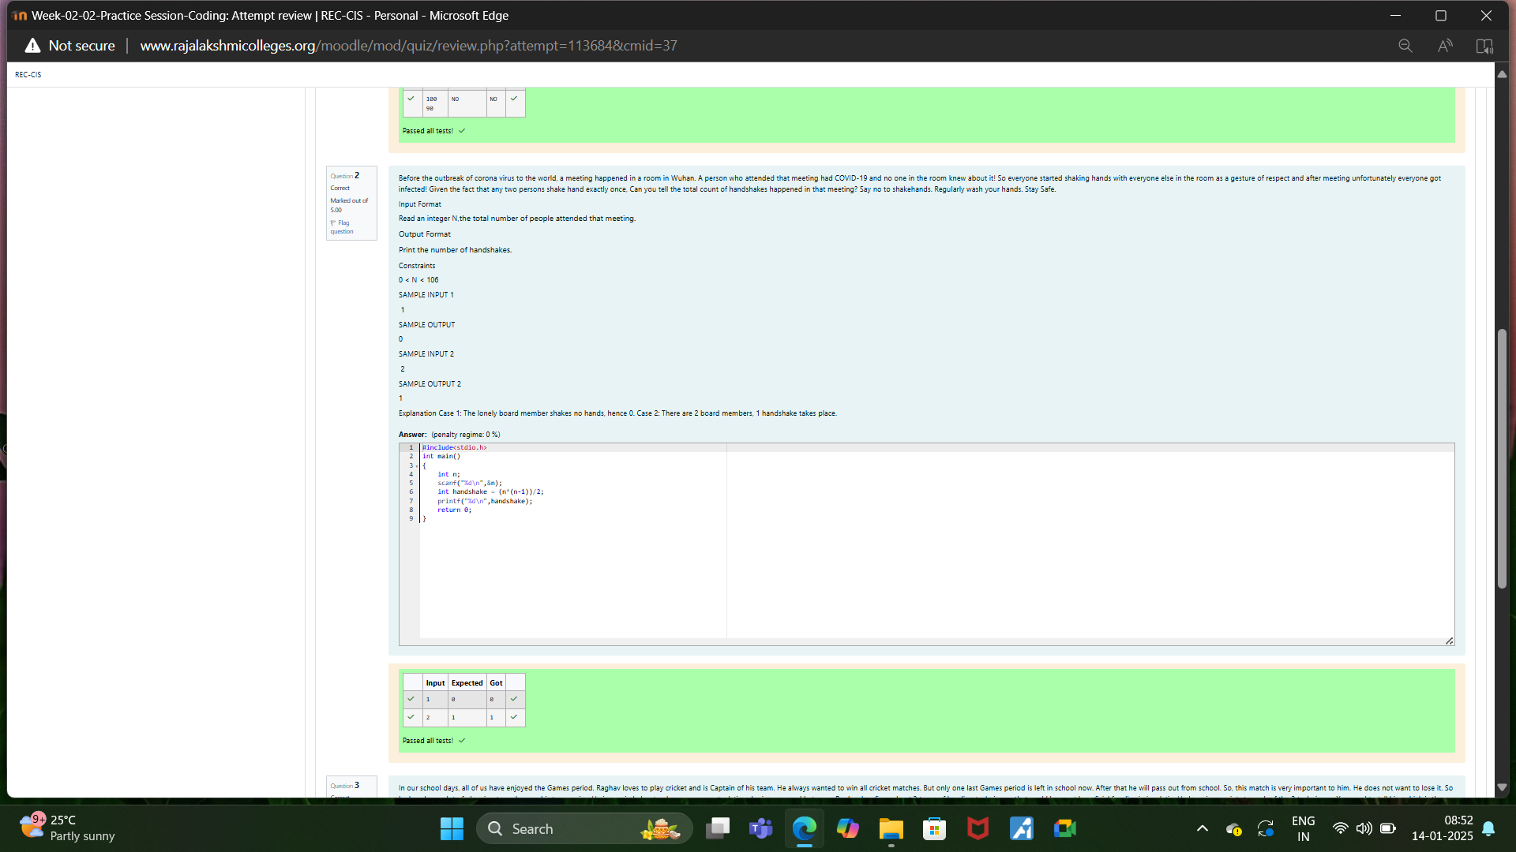

Week -02-02Practice Session – Coding

Reg No : 241801289

Name: Tamil selvan.K

Q3

